DEEP LEARNING BASICS

A feedforward Neural Network with L layers is to describe a mapping $f\left(r_{0};θ\right) :R^{N_{0}}↦R^{N_{L}}$, which is an input vector $r_{0}∈R^{N_{0}}$ to an output vector $r_{L}∈R^{N_{L}}$, and there are through L iterative processing steps:

$r_{l}=f\left(r_{l-1};θ_{l}\right), l=1,…,L$ (1)

Where $f\left(r_{l-1};θ_{l}\right) : R^{N_{l-1}}↦R^{N_{l}}$ is the mapping carried out by the $l$ th layer. This mapping depends on the output vector $r_{l-1}$ and a set of parameters $θ_{l}$. This work presents that $f\left(r_{l-1};θ_{l}\right)$ has the form

$f\left(r_{l-1};θ_{l}\right)=σ(W_{l}r_{l-1}+b_{l})$ (2)

the $l$ th layer is called *dense* or *full-connected* layer, where $W_{l}∈R^{N_{l}}×R^{N_{l-1}}, b_{l}∈R^{N_{l}}$, and $σ(∙)$ is an *activation* function, and $θ_{l}=\{W_{l}, b_{l}\}$. Common activation functions and layer types are listed in *Table. 1* and *Table. 2* respectively.

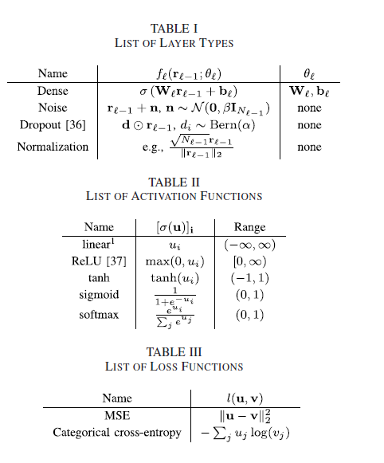

This paper uses labelled training data to train neural networks. For instance, the labelled data is a set of input and output vector pairs $(r_{0,i},r_{L,ⅈ}^{*})$, i=1,…,S, where $r_{L,ⅈ}^{*}$ is the desired output vector and $r_{0,i}$ is the input vector.

The training process is mainly to reduce the loss to minimum value:

$L\left(θ\right)=\frac{1}{S}\sum_{i=1}^{S}{l}(r_{L,ⅈ}^{*}, r_{L,i})$ (3)

Where $l\left(u, v\right):R^{N_{L}}×R^{N_{L}}↦R$ is the loss function, which is categorical cross-entropy function $-∑_{j}u_{j}\log{(v_{j})}$; and $r_{L,ⅈ}^{}$ is the output and we use $r_{0,i}$ as input. Several commonly used loss functions are presented in *Table.3*.

Then we use the most popular stochastic gradient decent (SGD) algorithm to find sets of parameters $θ$. The SGD starts with $θ=θ_{0}$ where $θ_{0}$ is some random initial parameters and then updates $θ$ iteratively as

$θ_{t+1}=θ_{t}-η∇\tilde{L}\left(θ_{t}\right)$ (4)

Where the learning rate $η>0$, and $\tilde{L}\left(θ_{t}\right)$ is the approximation of the categorical cross-entropy function.

Note that detailed description of Neural Networks is presented in [10].

[10] I. Goodfellow, Y. Bengio, and A. Courville, *Deep Learning*. Cambridge,

MA, USA: MIT Press, 2016.

This paper defines and trains NNs by the existing DL libraries presented in RELATED WORK. To simulate autoencoder concept from [8], this work mainly uses TesnsorFlow [40] and Keras [43].

[8] Timothy J. O’Shea and Jakob Hoydis. An introduction to machine

learning communications systems. CoRR, abs/1702.00832, 2017.

[40] M. Abadi *et al.* (2015). *TensorFlow: Large-Scale Machine Learning on*

*Heterogeneous Systems*. [Online]. Available: http://tensorflow.org/

[43] F. Chollet. (2015). *Keras*. [Online]. Available:

https://github.com/fchollet/keras